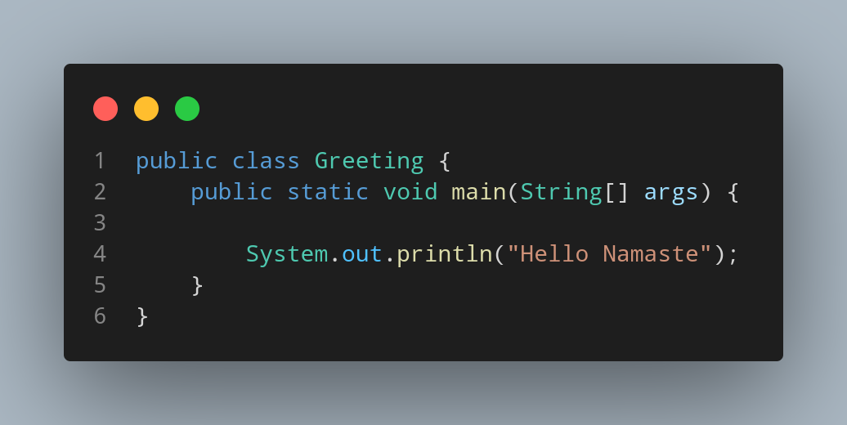

DOC →

File name Greeting is created so we create a class name Greeting inside the class we create a main function.We printed “Hello Namaste”.

